**Special Problem #3 – Ethan Hitchcock - 1408202**

*Introduction*

This problem explored how a linear array of antennas interacted with each other and the corresponding array factor pattern for different conditions. The equation for the Array Factor is given below.

For this equation, k is set to a constant 2pi for the wave number in air. N, d, θ, Φ, and ψ are variables defined for each section. ‘N’ represents the number of elements in a linear array. ‘d’ represents the spacing between elements as a coefficient of wavelengths. ‘θ’ and ‘Φ’ are variables used for the spherical coordinates system. ‘ψ’ represents the relative phase difference between two adjacent elements in radians.

Unless otherwise stated, assume the values are as follows for each set of results and discussion:

N = 2, d = ¼ λ, Φ = 90֯, θ is the independent variable

*Results and Discussion*

1. **Array Factor for a Single Element**

Figure 1 depicts the array factor about a single element source. The signal is evenly distributed in all directions as there are no other elements to cause superposition of the signal.

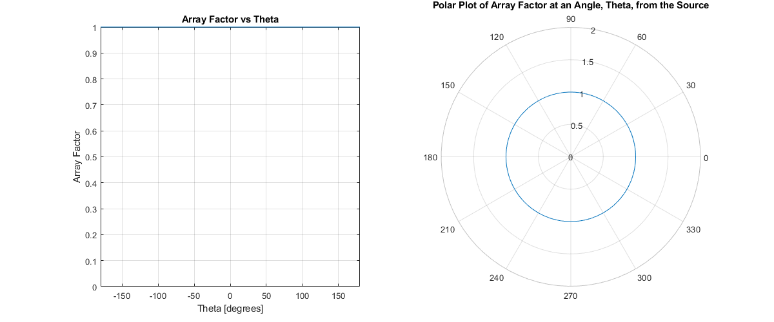

Figure 1 Array Factor Pattern for a Single Element

1. **Array Factor for Increasing Number of Elements**

Figure 2 through Figure 6 depict how the array factor changes as the number of elements in the array changes. As the number of elements in the array increases, the number of lobes increases. This is due to the interaction between the waves causing superposition. Additionally, as the number of elements in the array increases, the maximum array factor also increases. Adding more elements, given the conditions in the introduction, causes this array lobes to become narrower and for the array to endfire.

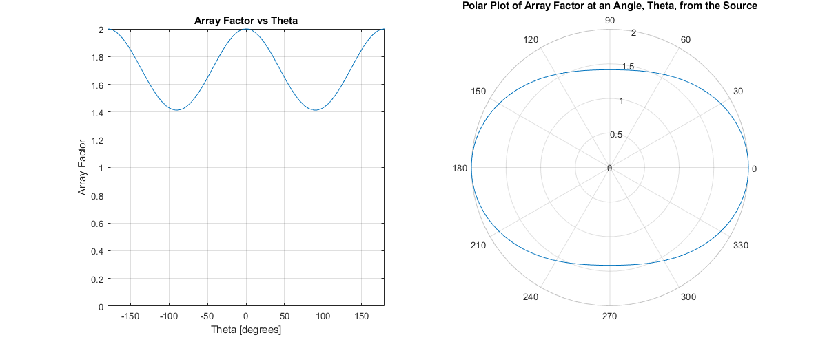

Figure 2 Array Factor for a 2 Element Array

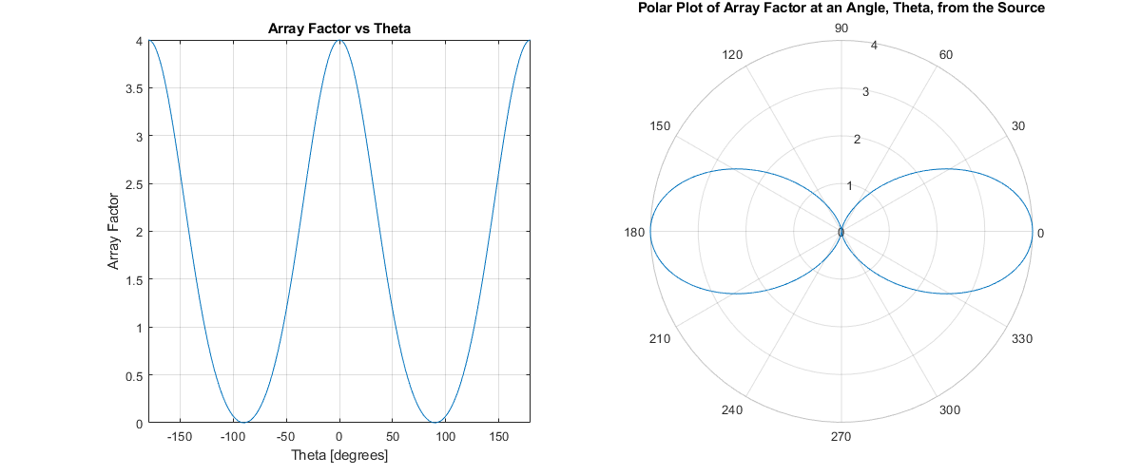

Figure 3 Array Factor for a 4 Element Array

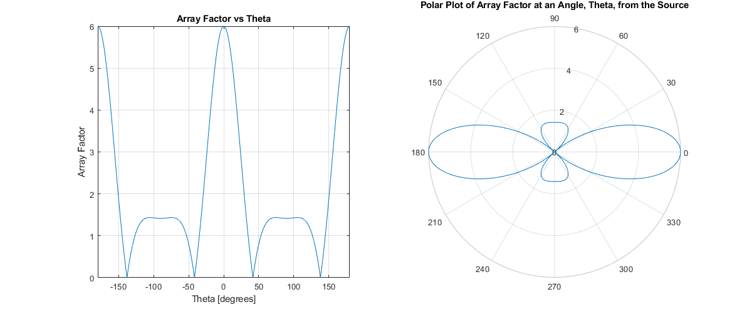

Figure 4 Array Factor for a 6 Element Array

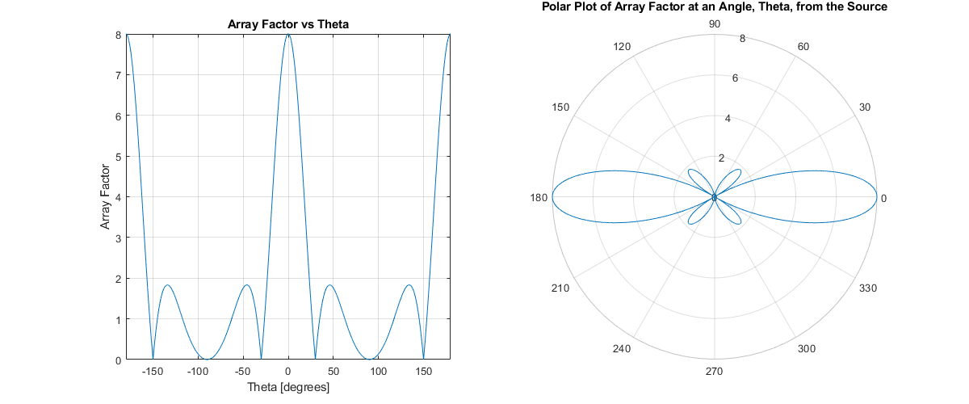

Figure 5 Array Factor for an 8 Element Array

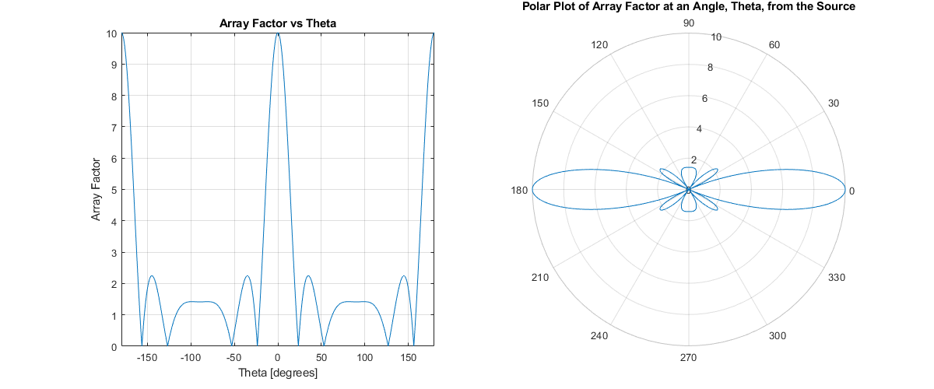

Figure 6 Array Factor for a 10 Element Array

1. **Array Factor for an increasing d**

Figure 7 through Figure 13 depict how the array factor changes as the number of elements in the array changes. As the number of elements in the array increases, the number of lobes increases. Unlike the case for an increasing number of elements, the directionality of the antenna array is more evenly distributed. The antenna array is more biased towards broadfire signals for d > ½ λ. As d gets smaller, the array factor approaches its maximum value for all angles of θ from the source.

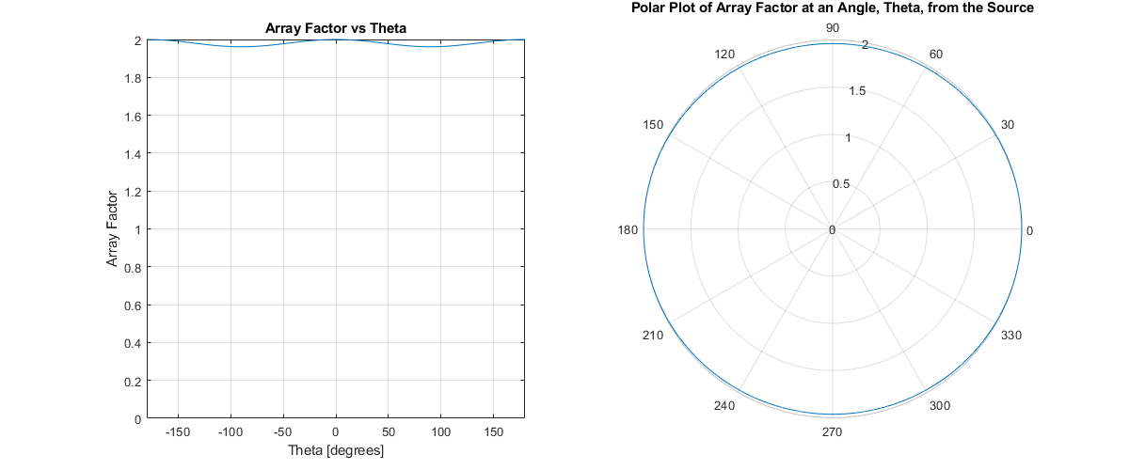

Figure 7 Array Factor for a d value of 1/16λ

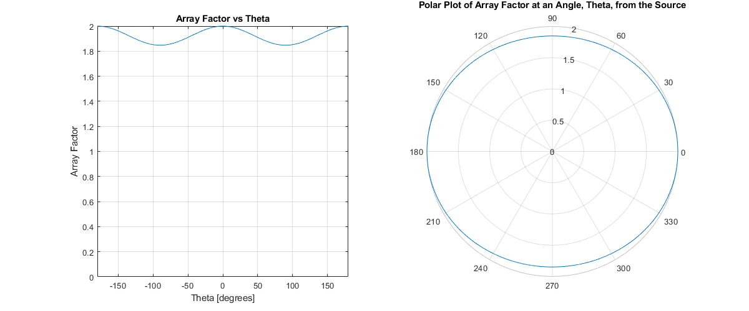

Figure 8 Array Factor for a d value of 1/8λ

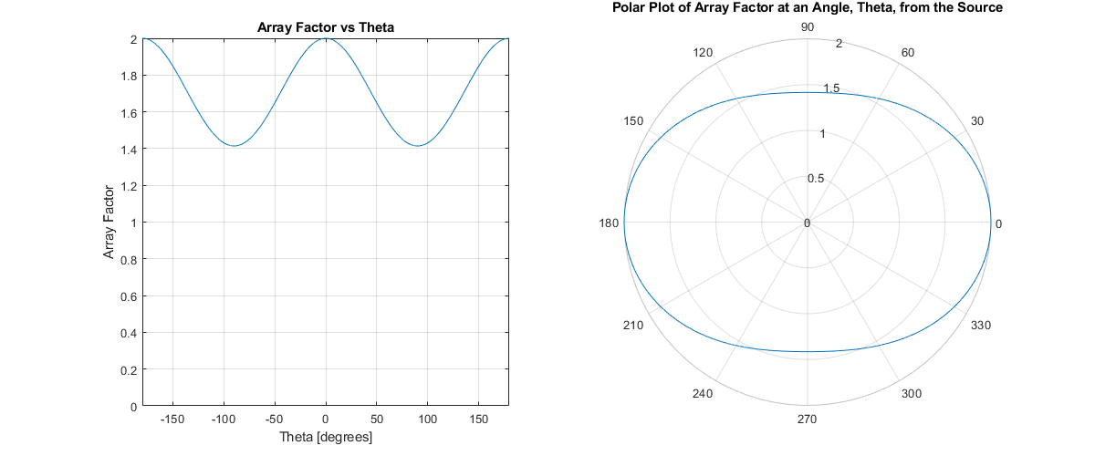

Figure 9 Array Factor for a d value of 1/4λ

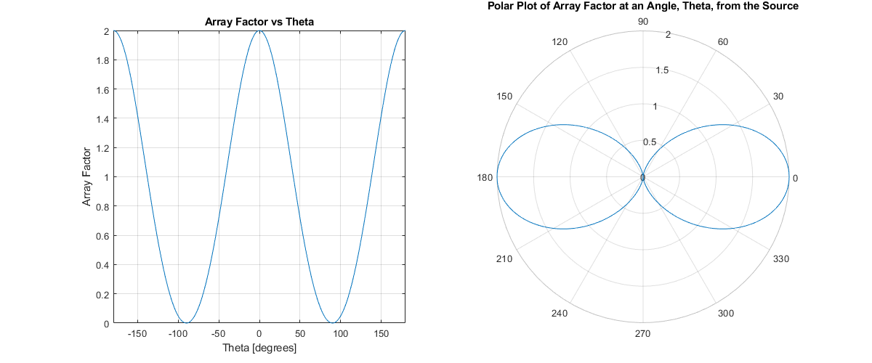

Figure 10 Array Factor for a d value of 1/2λ

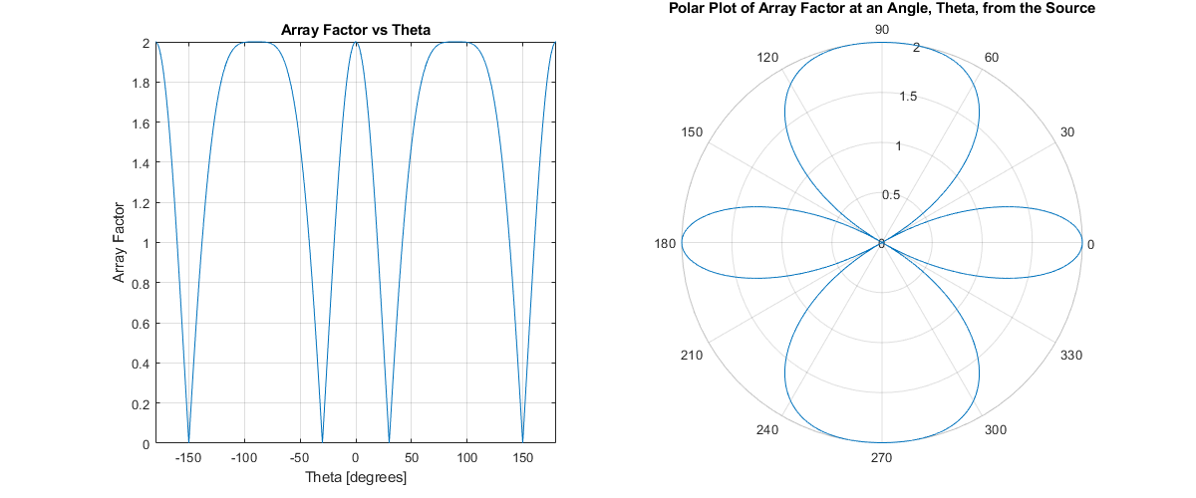

Figure 11 Array Factor for a d value of 1λ

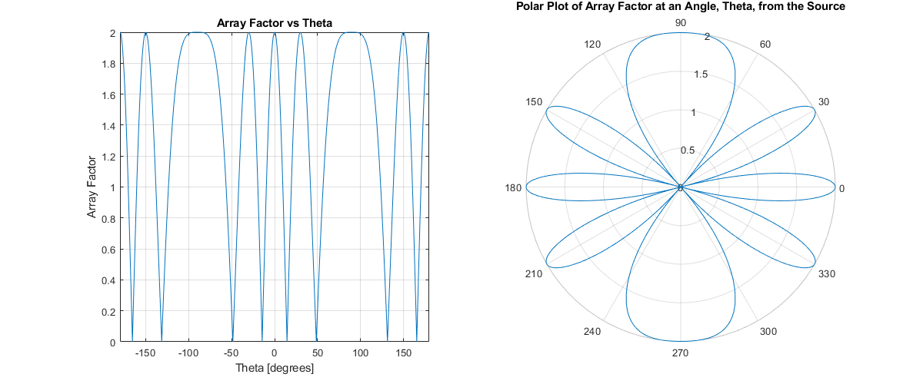

Figure 12 Array Factor for a d value of 2λ

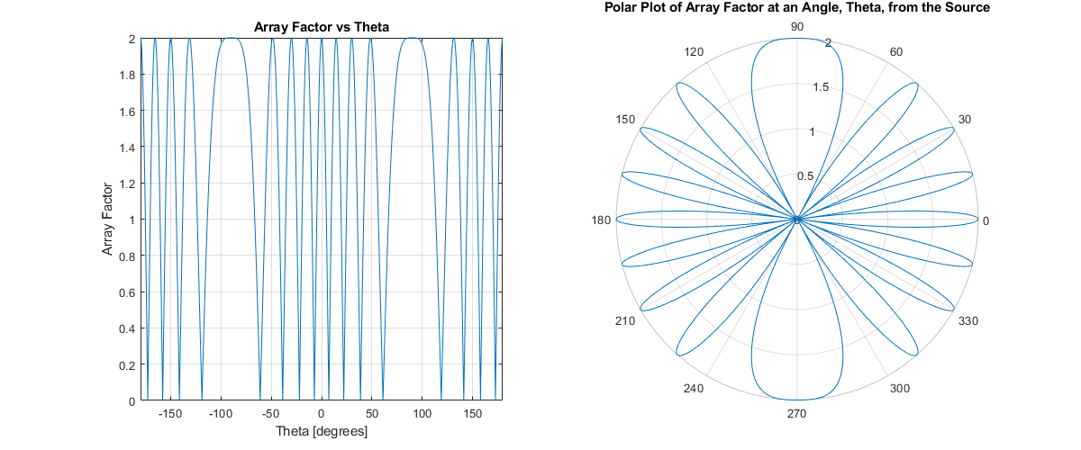

Figure 13 Array Factor for a d value of 4λ

1. **Array Factor for Increasing Relative Phase Difference**

Figure 14 through Figure 25 show the effect of a change in the relative phase difference shift on the array factor. As the relative phase difference shifts from -150֯ to 180֯ the directionality of the element array shifts. For a relative phase difference of 0֯ there is no shift in the directionality of the antenna array. For negative angle phase difference shifts, the directionality of the antenna array is shifted towards the 90֯ direction. For positive angle phase difference shifts, the directionality of the antenna array is shifted towards the 270֯ direction. When the relative phase difference is +/-180֯, the antenna array is completely broadfiring.

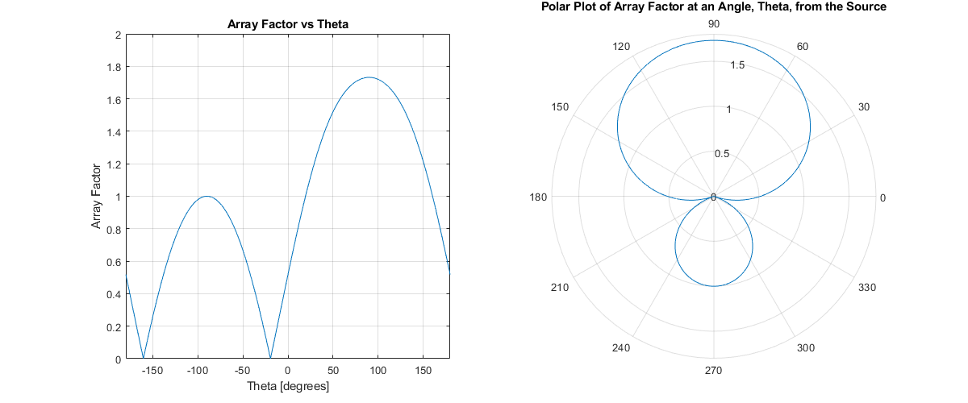

Figure 14 Array Factor for ψ = -150֯

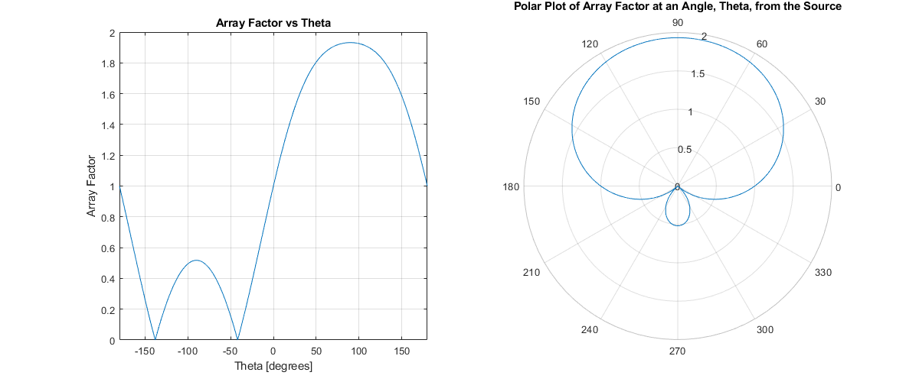

Figure 15 Array Factor for ψ = -120֯

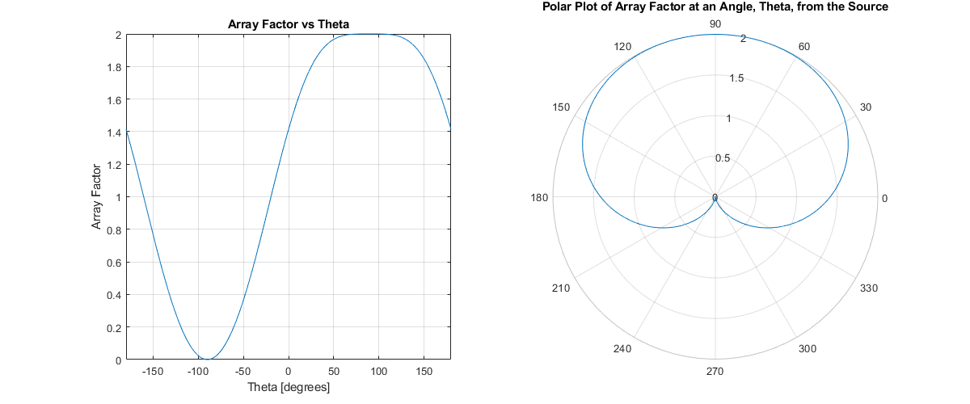

Figure 16 Array Factor for ψ = -90֯

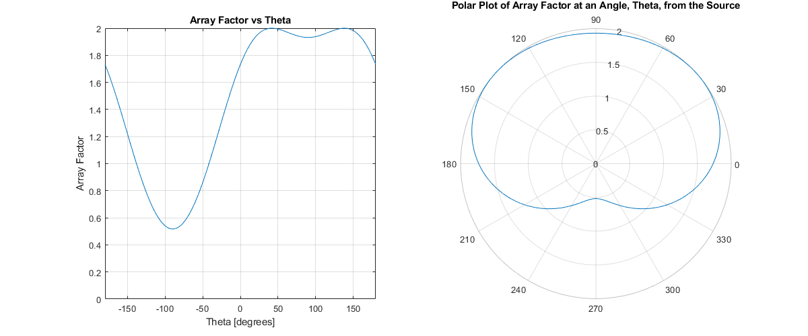

Figure 17 Array Factor for ψ = -60֯

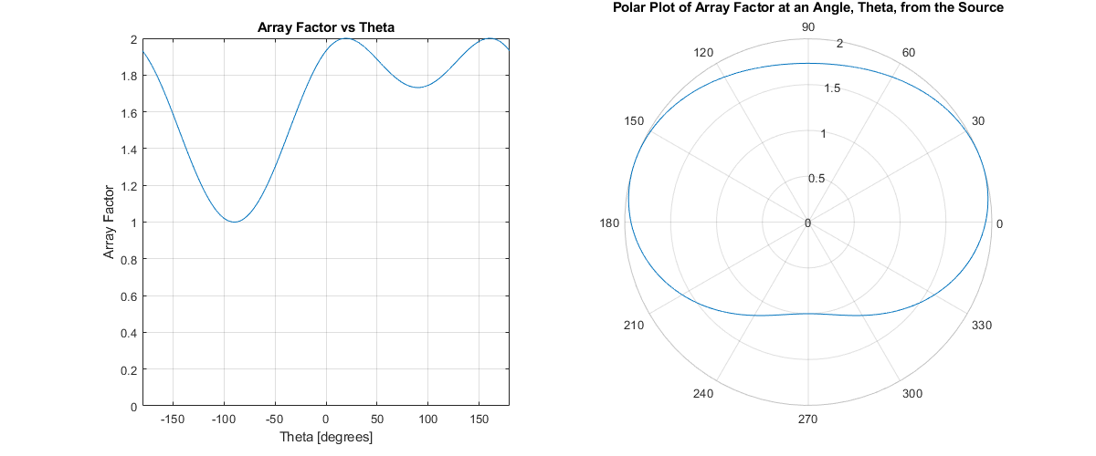

Figure 18 Array Factor for ψ = -30֯

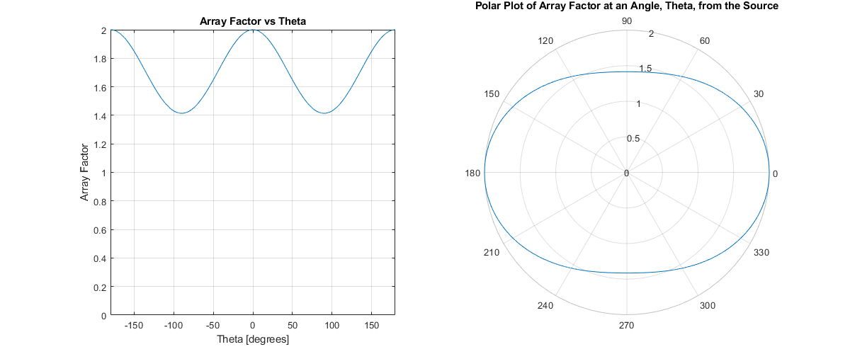

Figure 19 Array Factor for ψ = 0֯

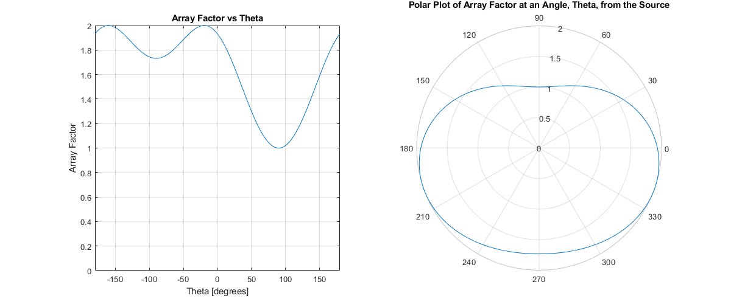

Figure 20 Array Factor for ψ = 30֯

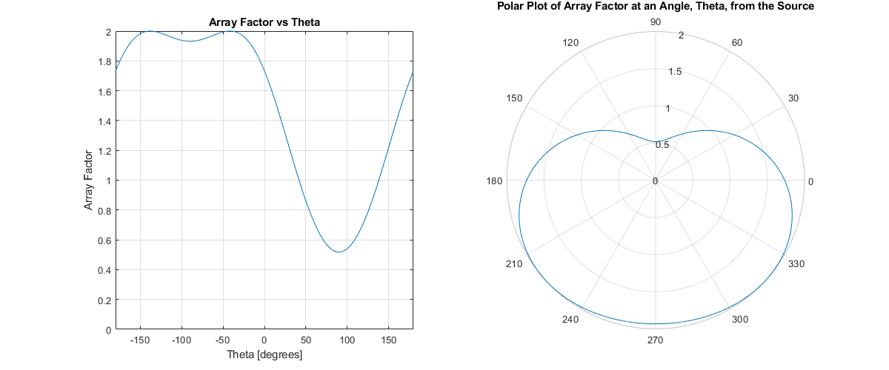

Figure 21 Array Factor for ψ = 60֯

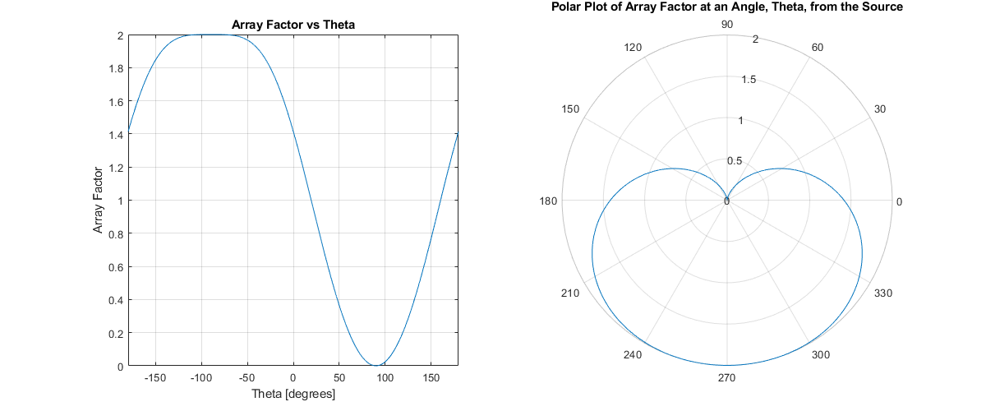

Figure 22 Array Factor for ψ =90֯

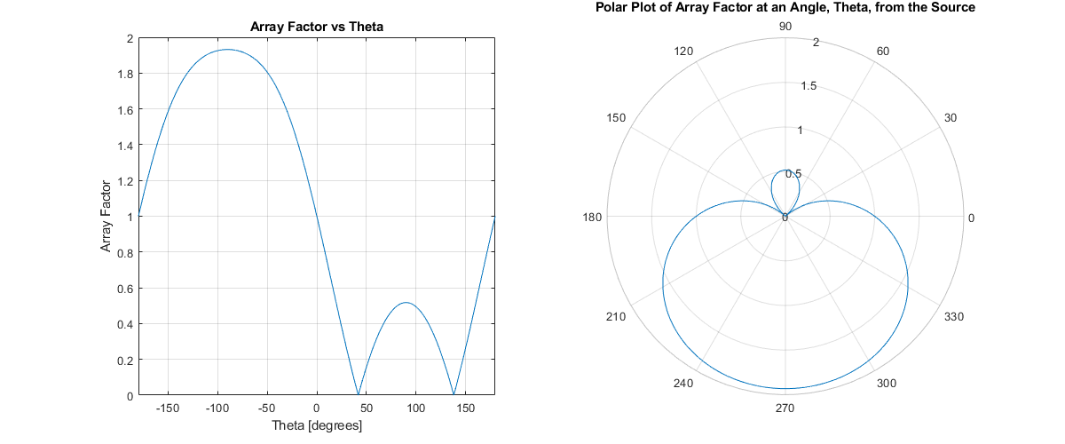

Figure 23 Array Factor for ψ = 120֯

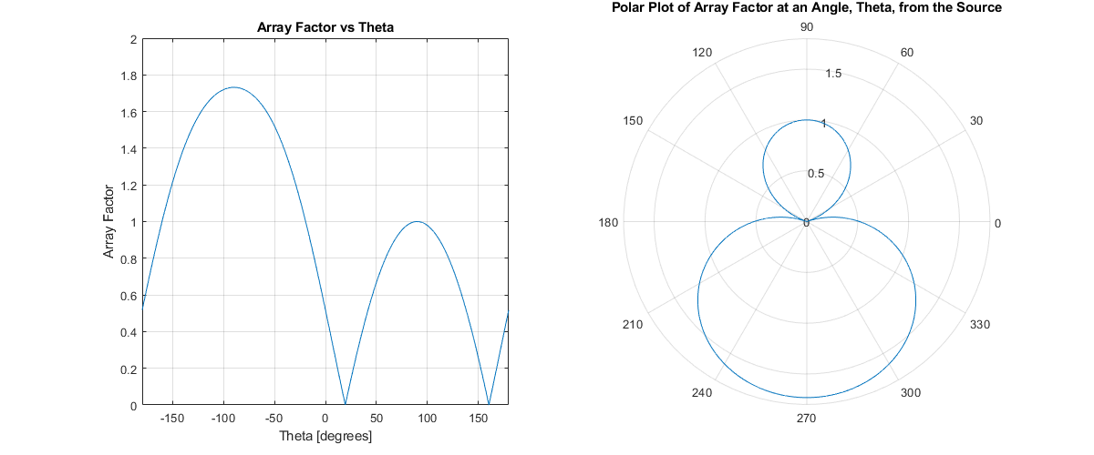

Figure 24 Array Factor for ψ = 150֯

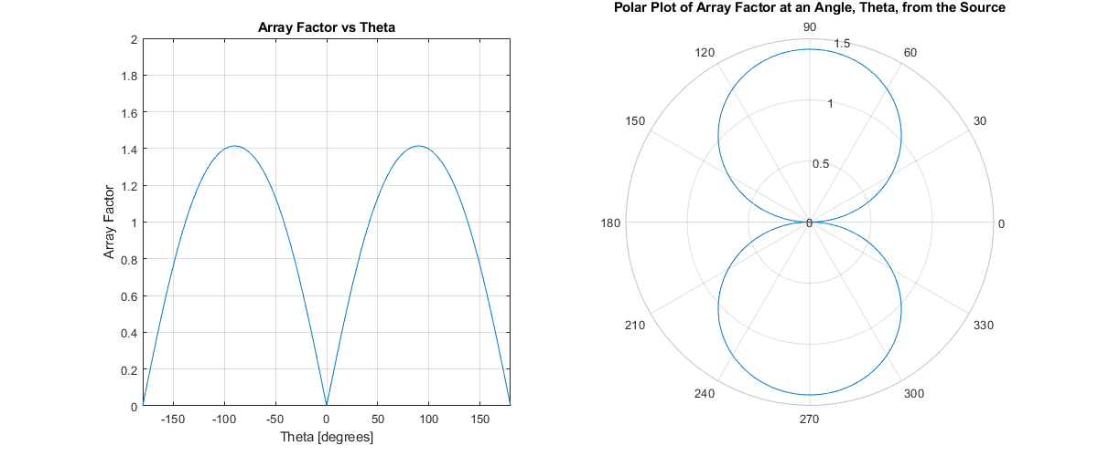

Figure 25 Array Factor for ψ = 180֯

1. **Array Factor for an Increasing Value of Phi**

Figure 26 through Figure 31 show the effect of a changing Φ value where θ is the independent variable. Due to the nature of a sinusoid, the patterns for Φ = 30֯ and Φ = 150֯ are equivalent, as are the patterns for Φ = 60֯ and Φ = 120֯. For Φ = 180֯, the element array will function like a single antenna but with twice the array factor as this is a 2-element array.

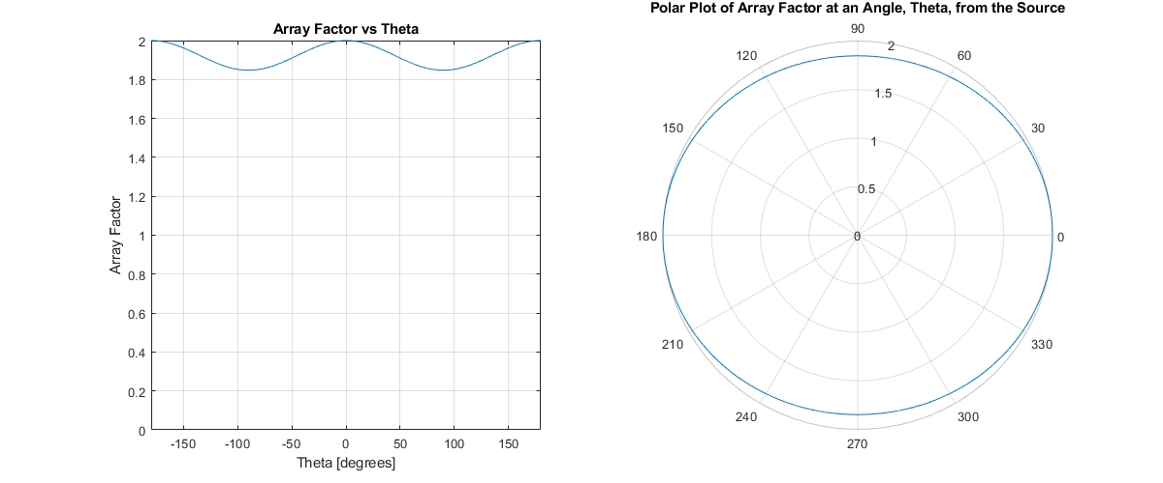

Figure 26 Array Factor for Φ = 30֯

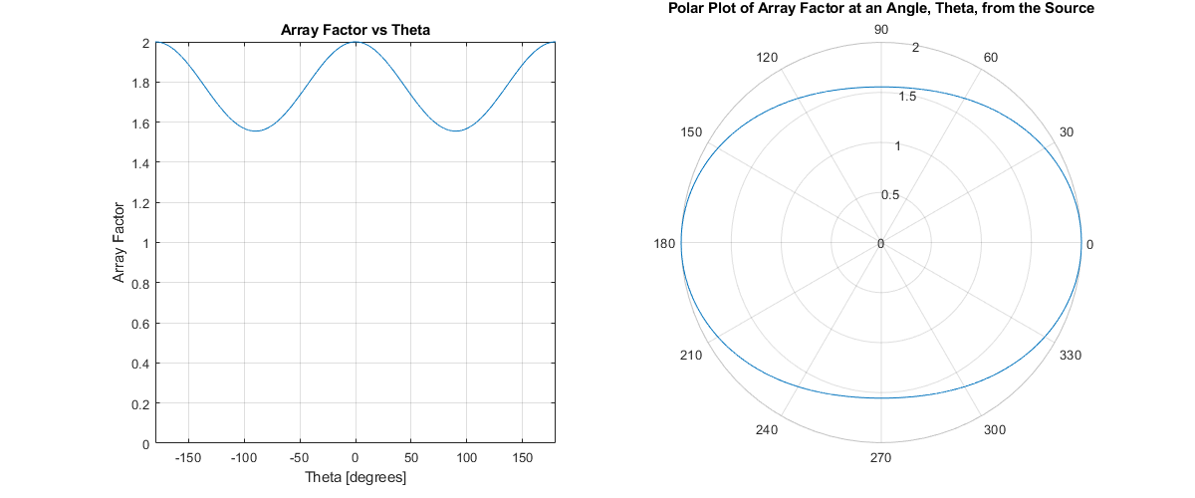

Figure 27 Array Factor for Φ = 60֯

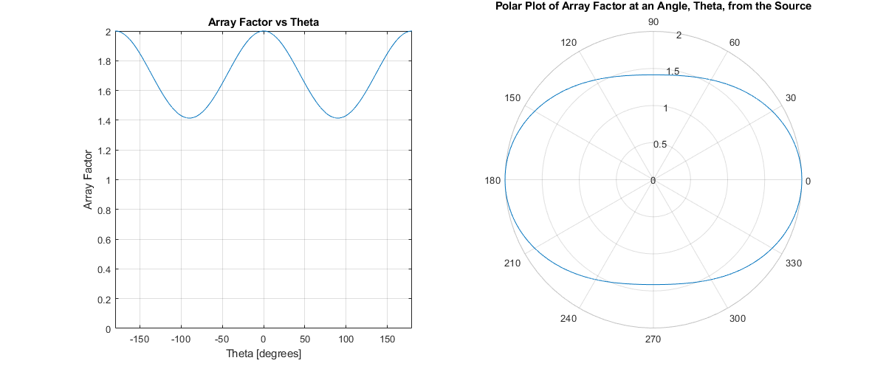

Figure 28 Array Factor for Φ = 90֯

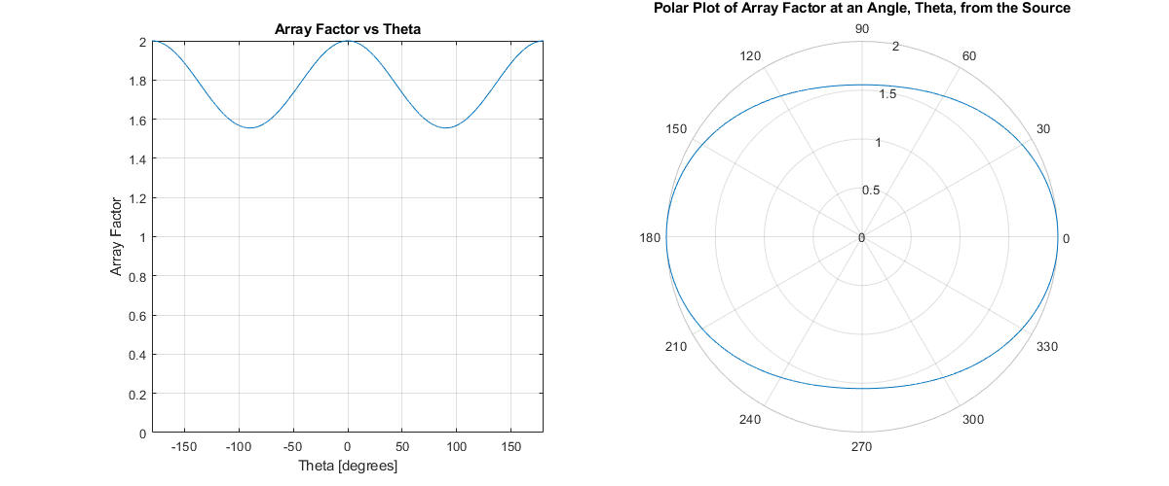

Figure 29 Array Factor for Φ = 120֯

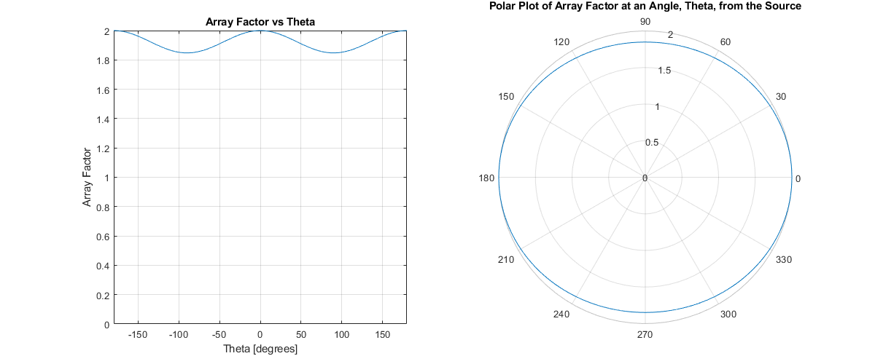

Figure 30 Array Factor for Φ = 150֯

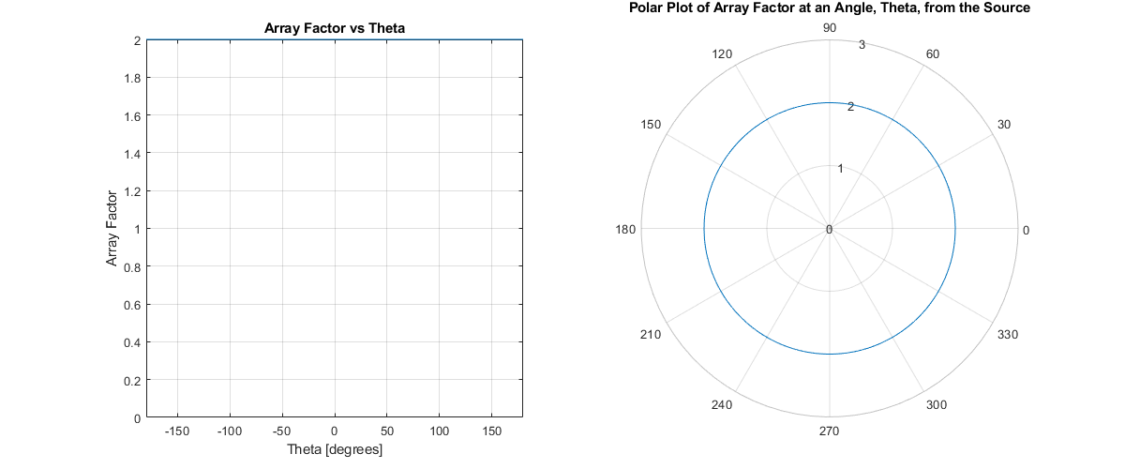

Figure 31 Array Factor for Φ = 180֯

*Conclusion*

The array factor pattern for an antenna array can be manipulated by adjusting both physical and/or electrical properties of the array. This can allow for an omnidirectional signal, or a more directed signal depending on the values chosen for the variables indicated throughout the report. The strength of the signal can be improved by adding additional elements to the array, however, superposition of the waves can result in a modified directionality.